# Tune the PID to get best results without noises, resolution of altitude = 0.2 m for case 2: isothermal balloon

## Random noise sensor = 0.5 m,

Comment: This is a very large amplitude, since we assume that this is the Gaussian noise of the sensor.

The appropriate amplitude for this noise should be equal to the resolution of the altimeter???

## Random noise sensor = 0.5; wind amplitude = 3 m (10 seconds)

Comment:

This indicates that the high amplitude, short-time period noise does not affect the performance of the system.

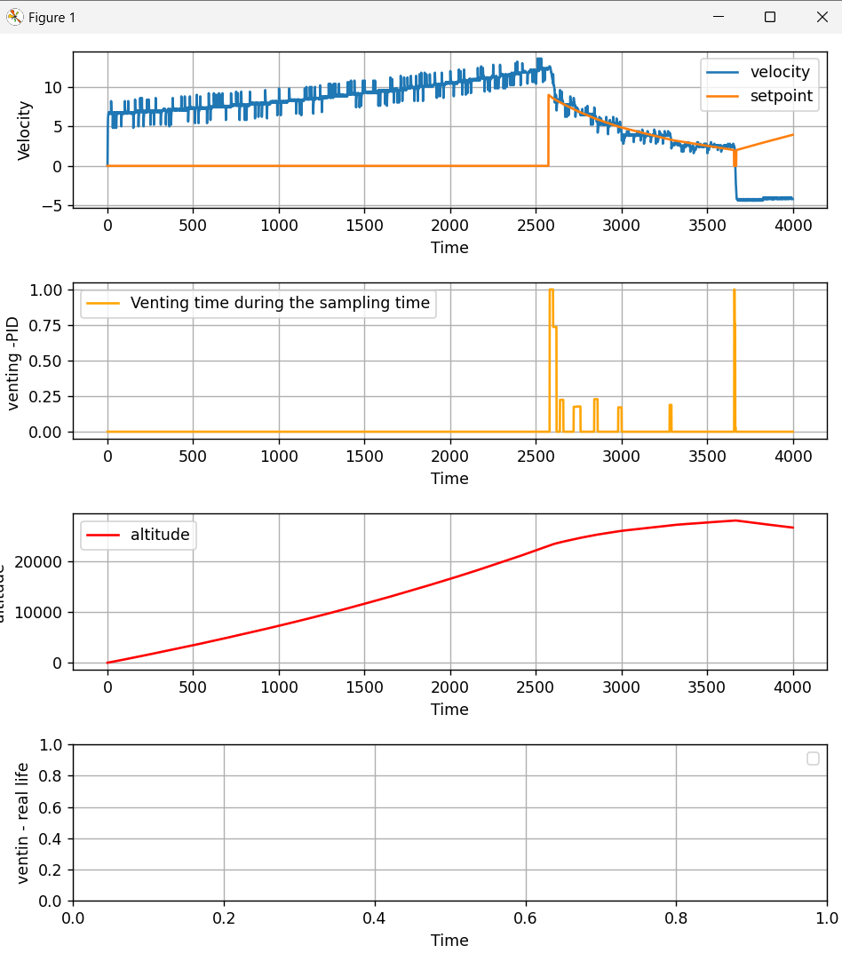

## Random noise sensor = .2, wind amplitude = 3, time-period = 100 seconds

# FINAL CONCLUSIONS for isothermal balloon

* This controller can adapt with:

+ High amplitude, long-time noise

+ Small amplitude, short-time noise

* We don’t need to worry about the noise???

# Case 3: adiabatic balloon

M = 7kg, V0 =15m3 => maximum height = 28.5 km => why this thing has the max

# Case 4: T_in = T_out

Max height about 28 km

How to estimate the altitude, velocity from altimeter with simulated noise?

* What sensor do we use
* Response time of altimeter => 10Hz variables
* Random noise of altimeter => 0.2 (m) variables

Target altitude 28 km

Isothermal